**personal blog(travel blog)**

**Team Members**

**1.PRIYA SAKTHI A**

**2.SHARMILA R**

**3.SUJITHA**

**4.JAISHREE R**

**Building a Static Web Apps:**

create an IBM cloud account,static web app on IBM Cloud® Object Storage, including creating a bucket, uploading content, and configuring your new website.

Hosting static websites with IBM Cloud Object Storage serves static content for public access giving users flexibility, ease of delivery, and high availability.

**steps followed to create IBM cloud account:**

**Step1:**

Go to myclass.skillup.online platform and search for an introduction to cloud.

**Step2:**

Then go to Module1 and click the obtain feature code to obtain the feature code.then click to activate the account.

**Step3:**

Then you will be redirected to the cloud.ibm.com and then type our registered email id and password.

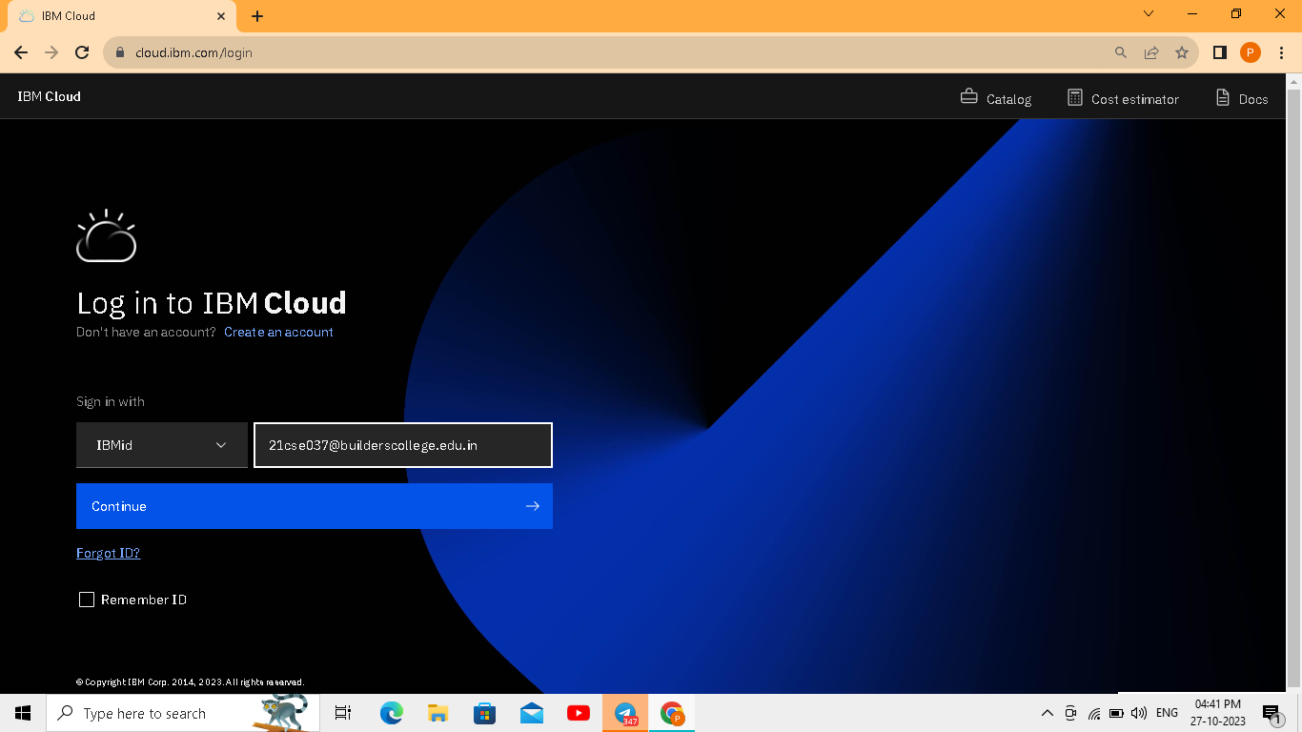

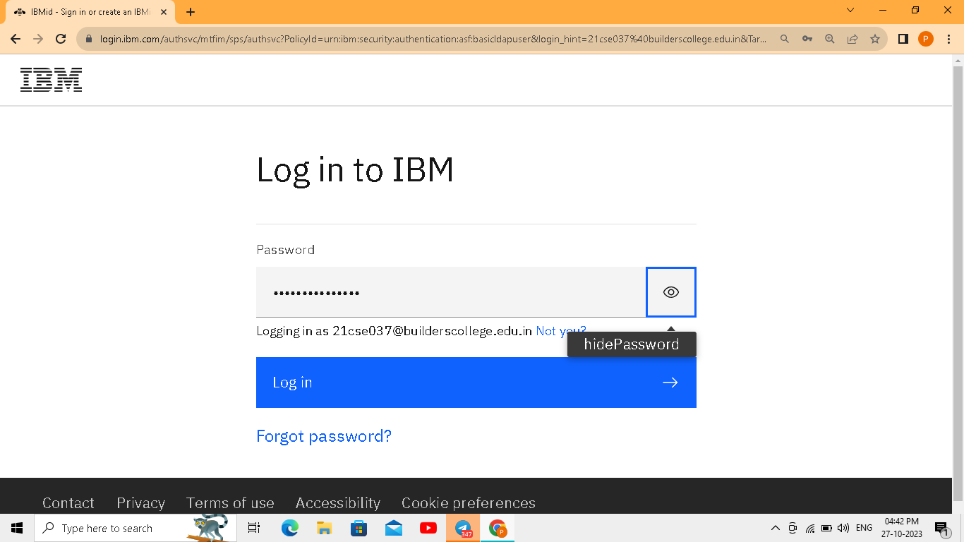

**Step4:**Then you will be redirected to the dashboard

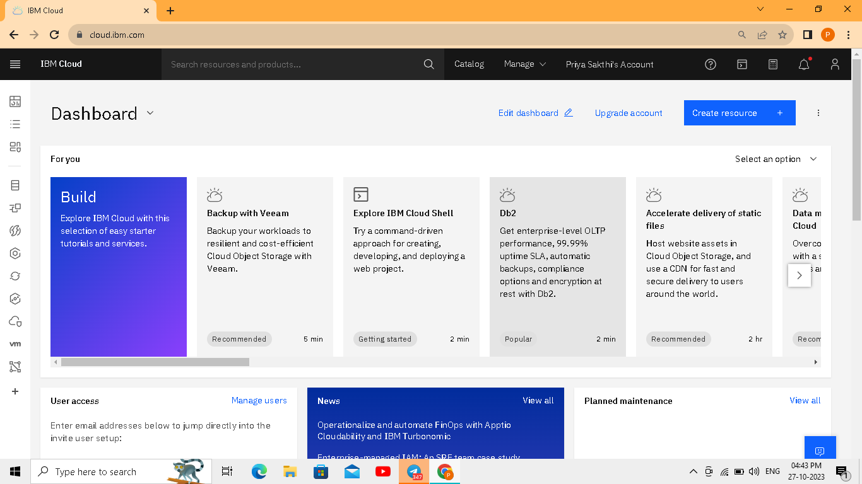

**Step5:**Go to search bar create object storage 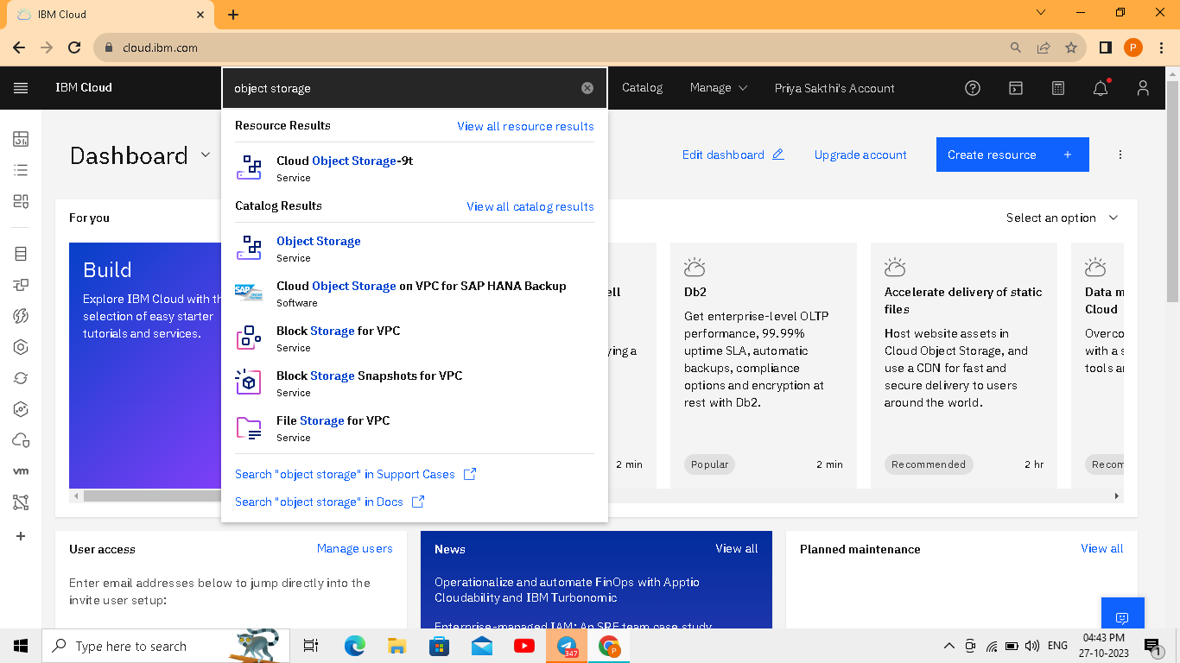

**Step6:**Next go to bucket

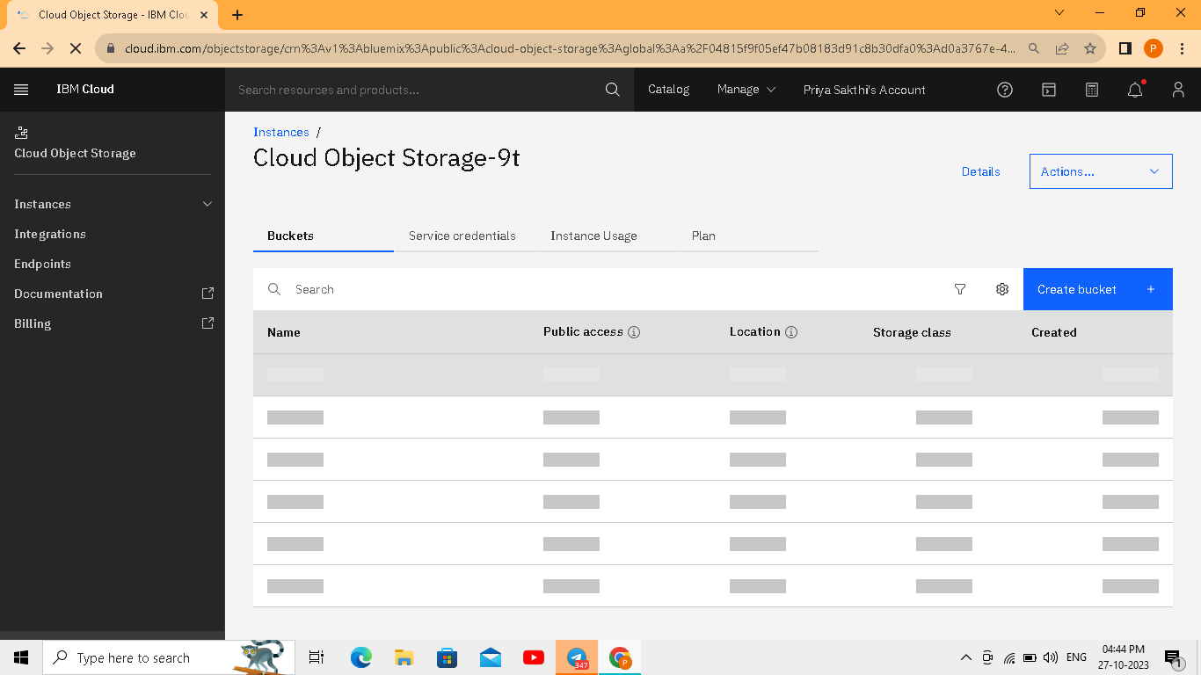

**Step7:**create bucket

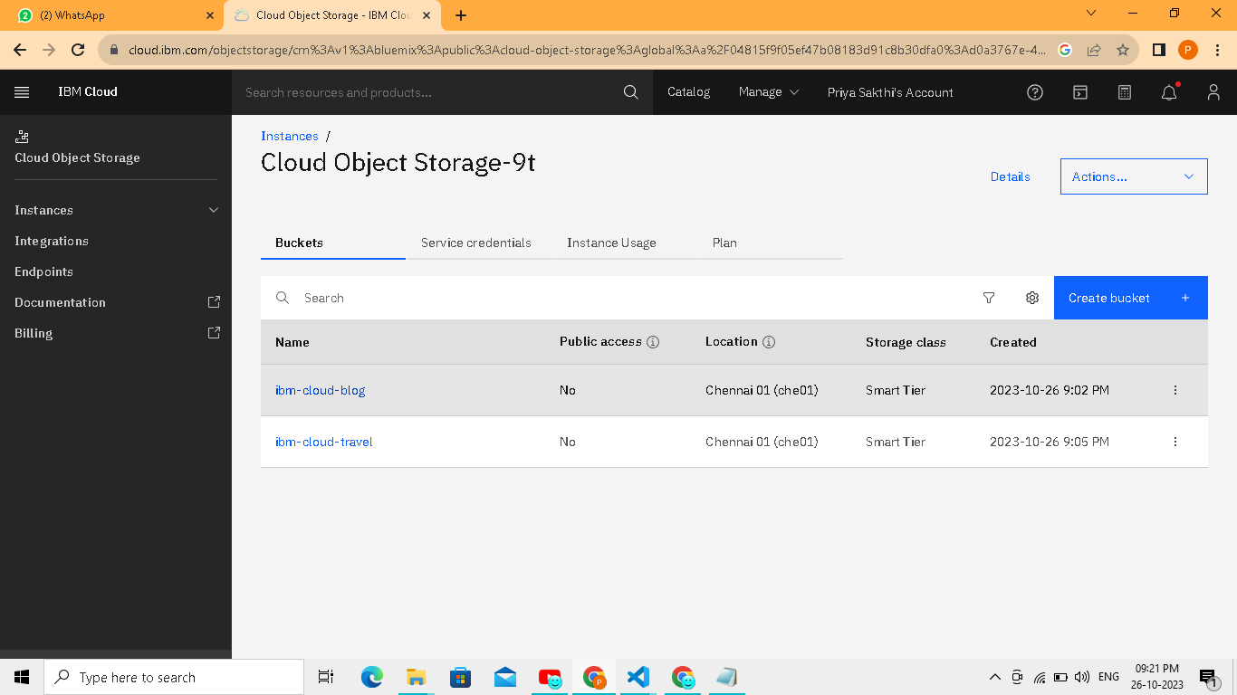

**Step8:**Upload files

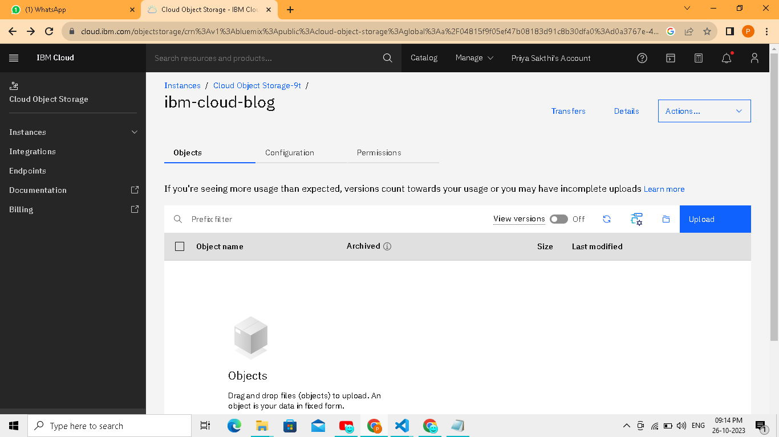

**Step9:**go to access policies

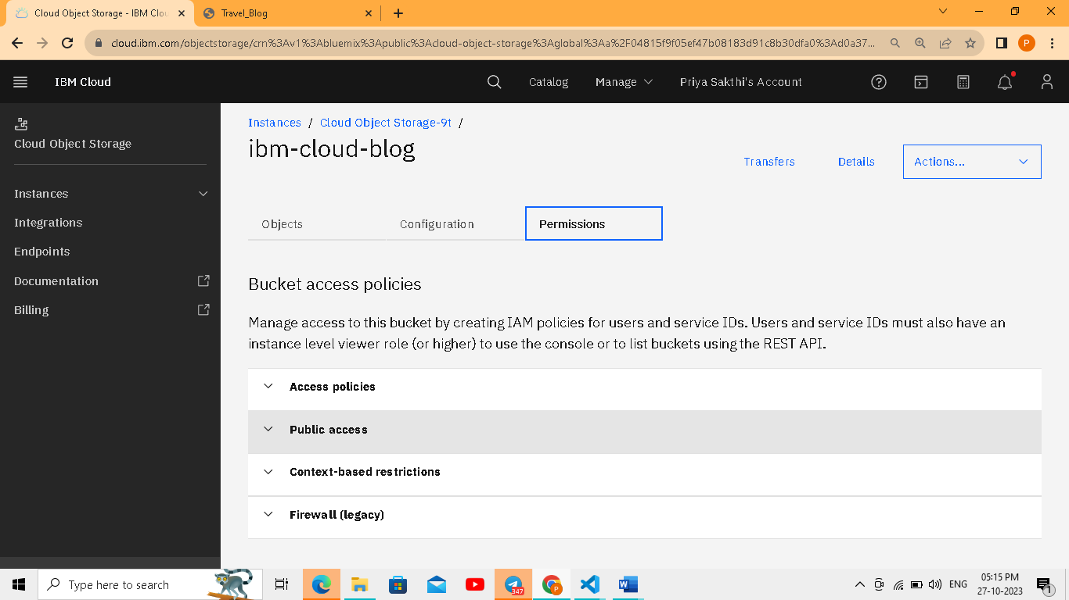

**Step10:**Go to public access

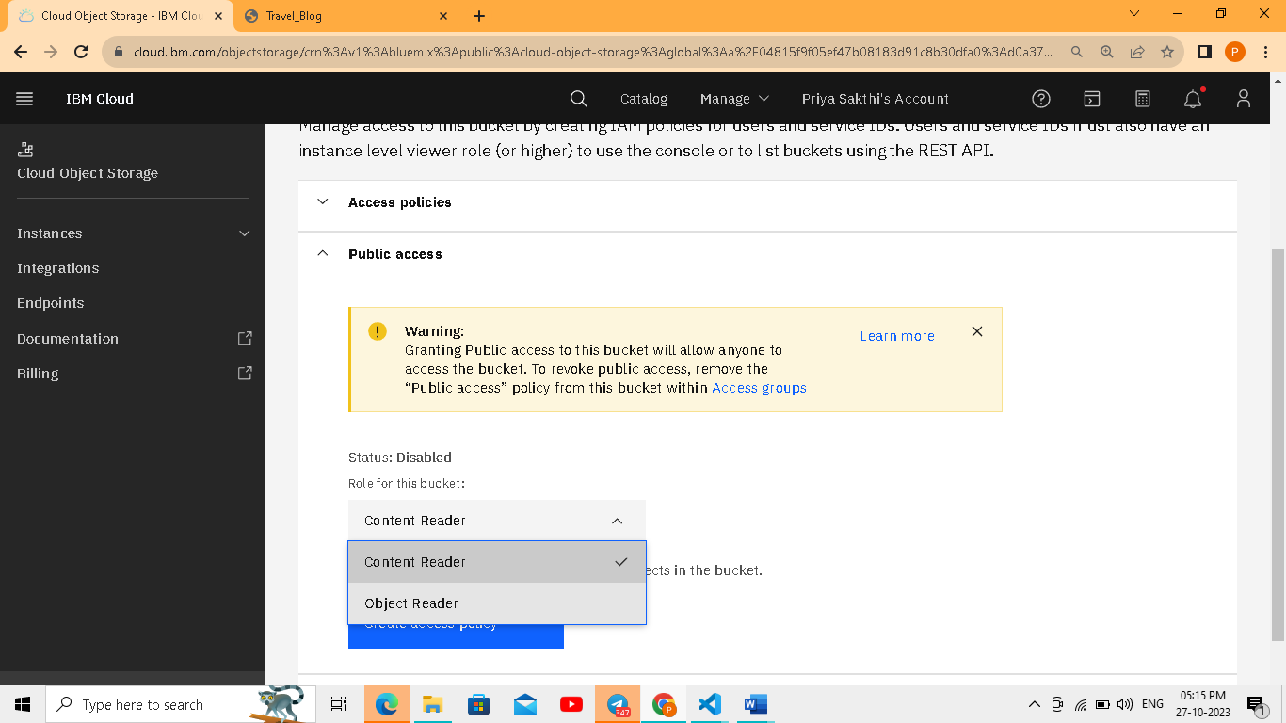

**Step11:**Create access policy

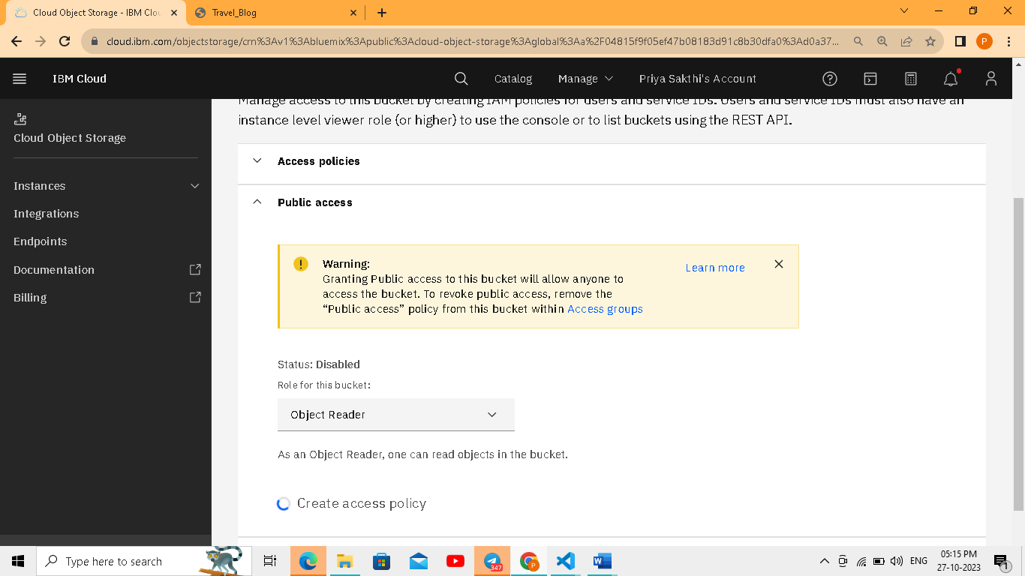

**step12:Enable the public access**

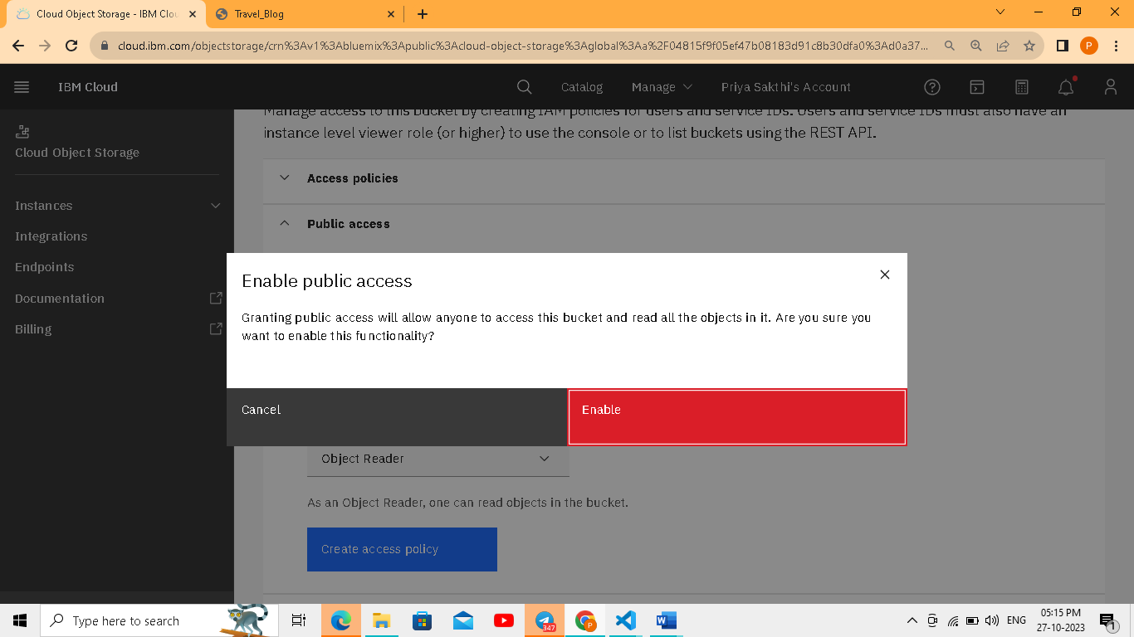

**Step13:**Access policy created

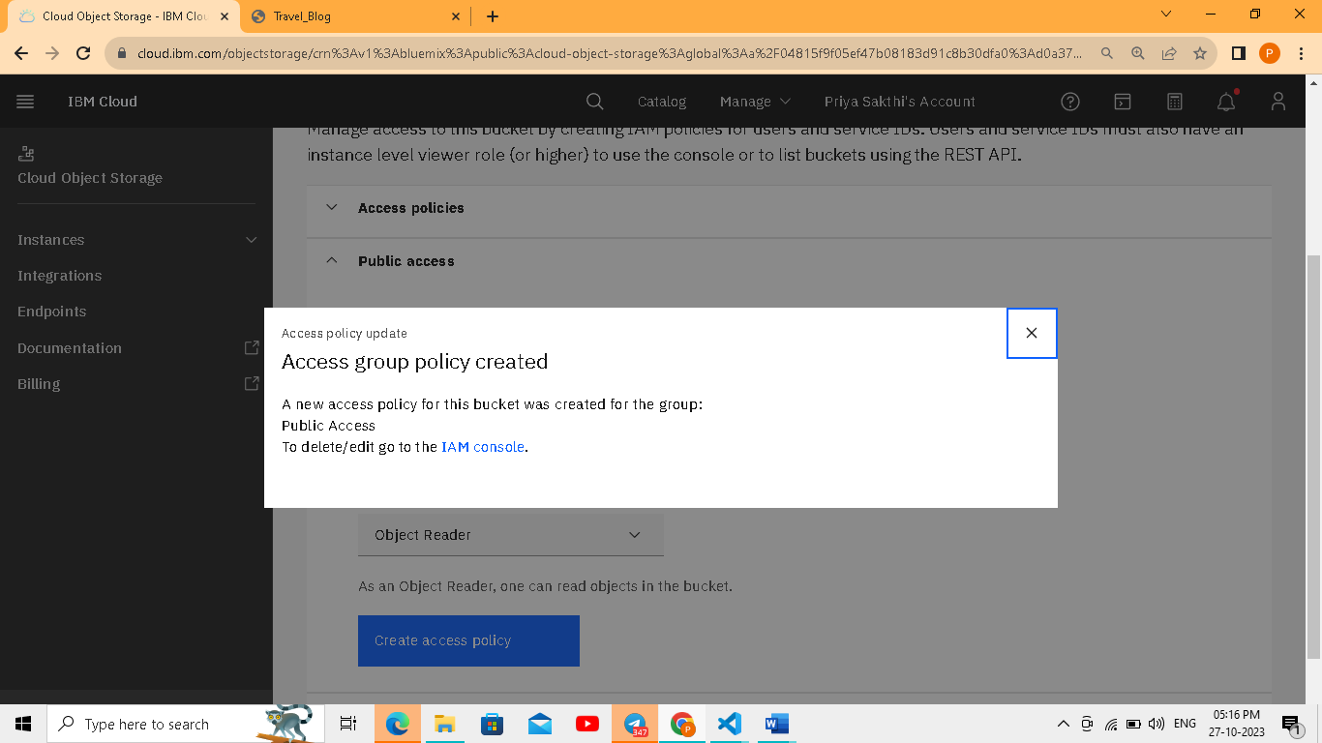

**Step14:**Access policy activated

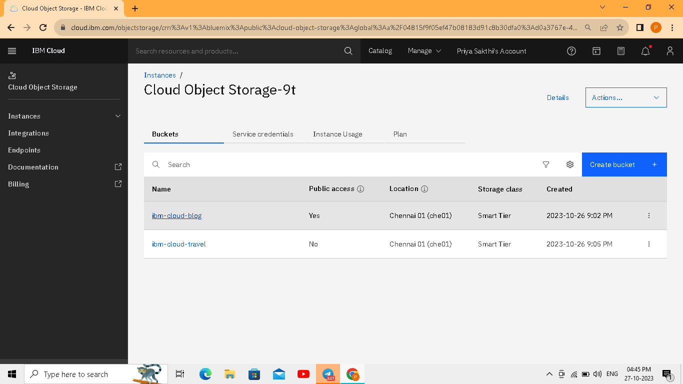

**Step15:**Upload content to your bucket

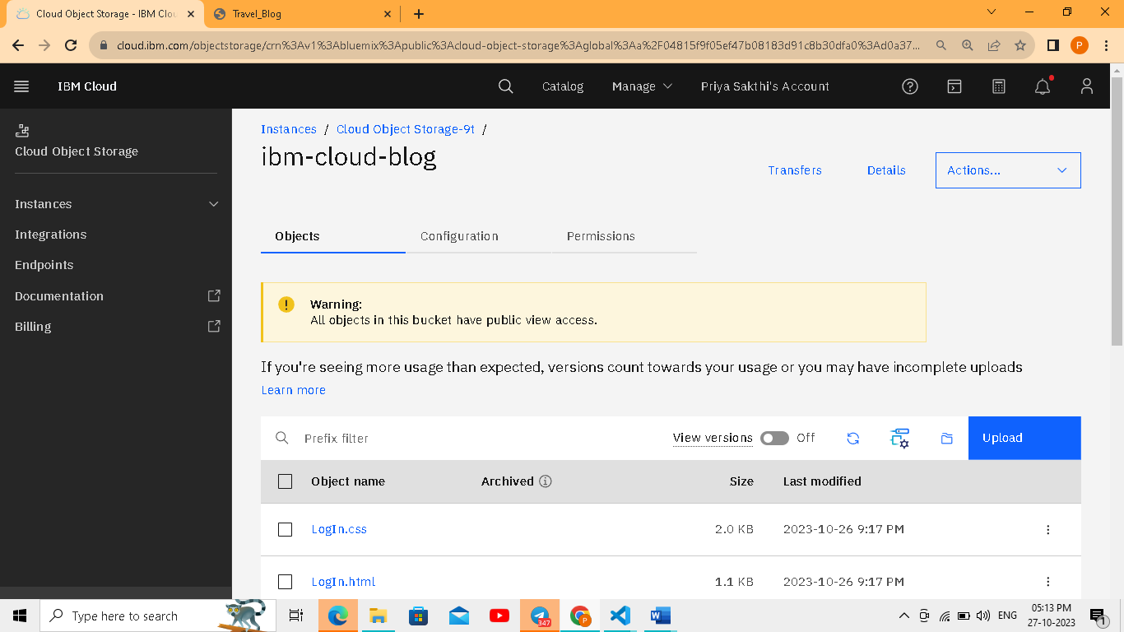

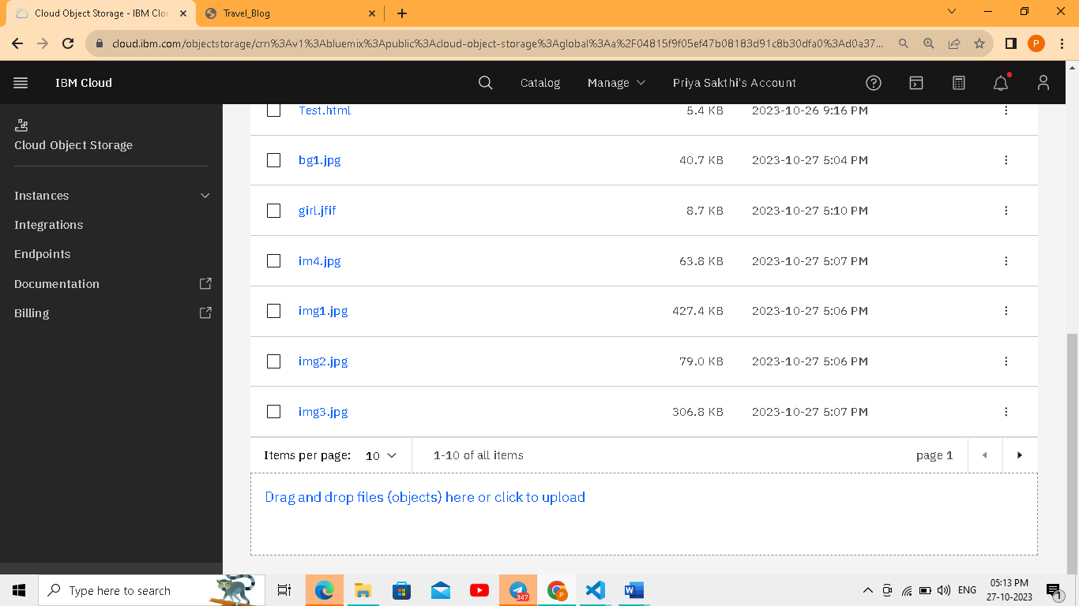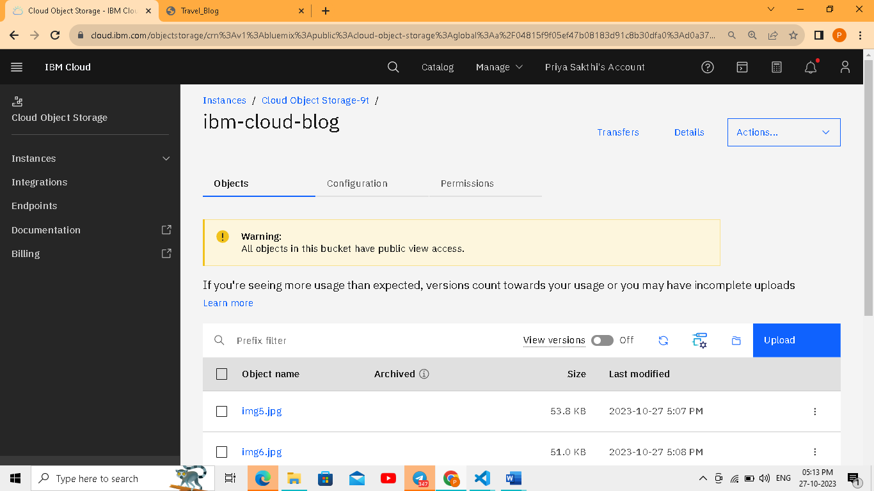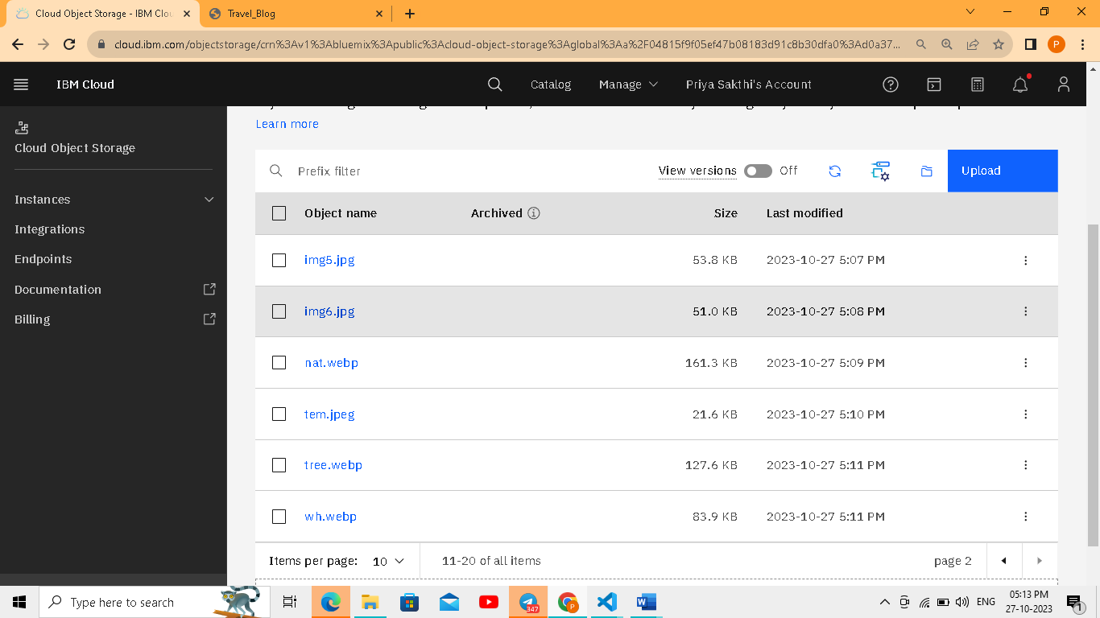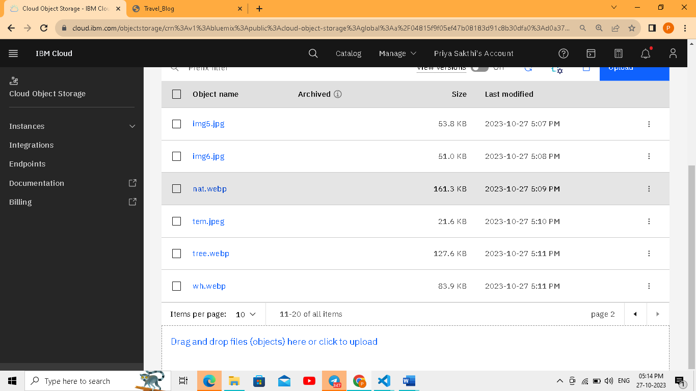

**Step16:**Click the file test.html

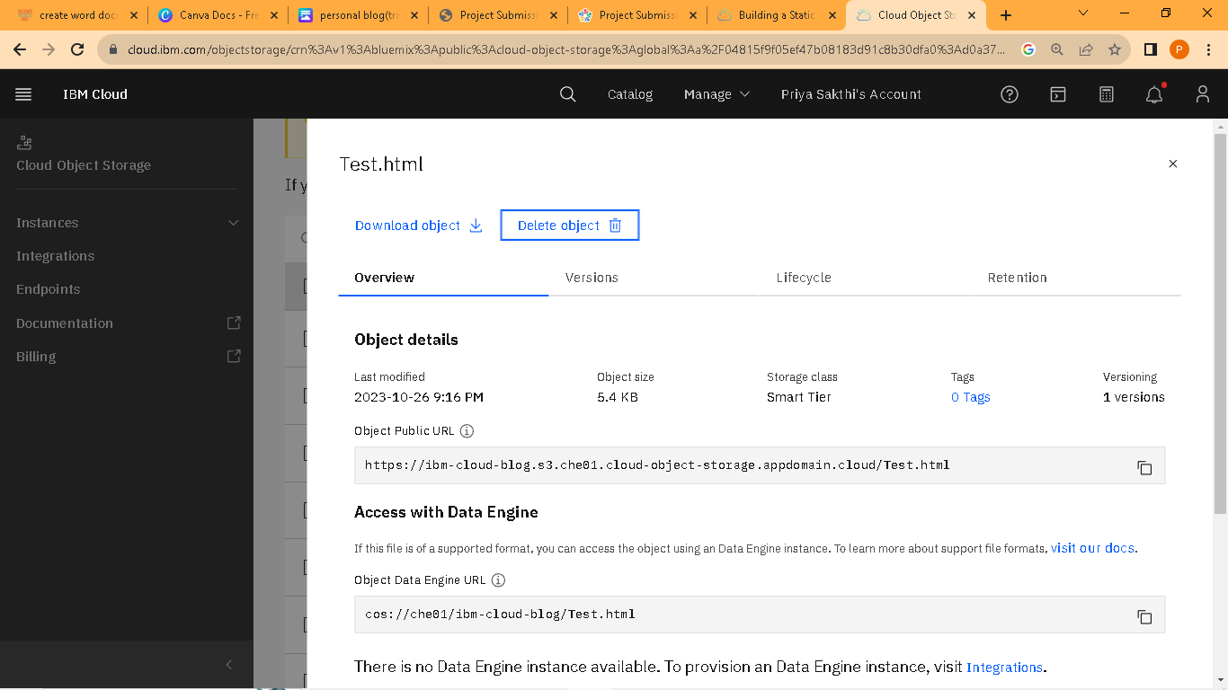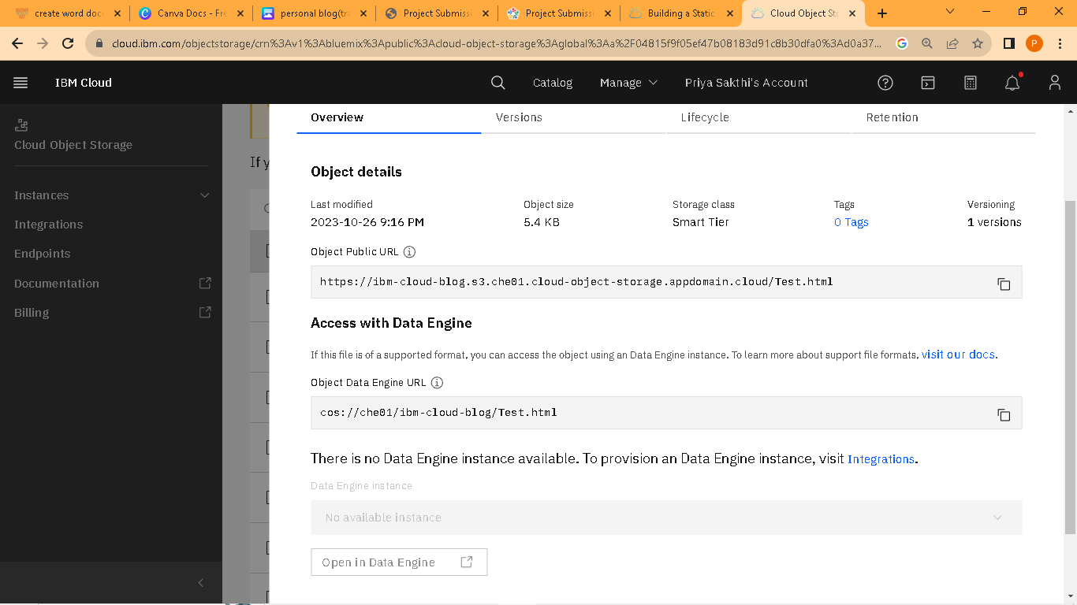

**Step17:**Copy the URL put into the new tab

https://ibm-cloud-blog.s3.che01.cloud-object-storage.appdomain.cloud/Test.html

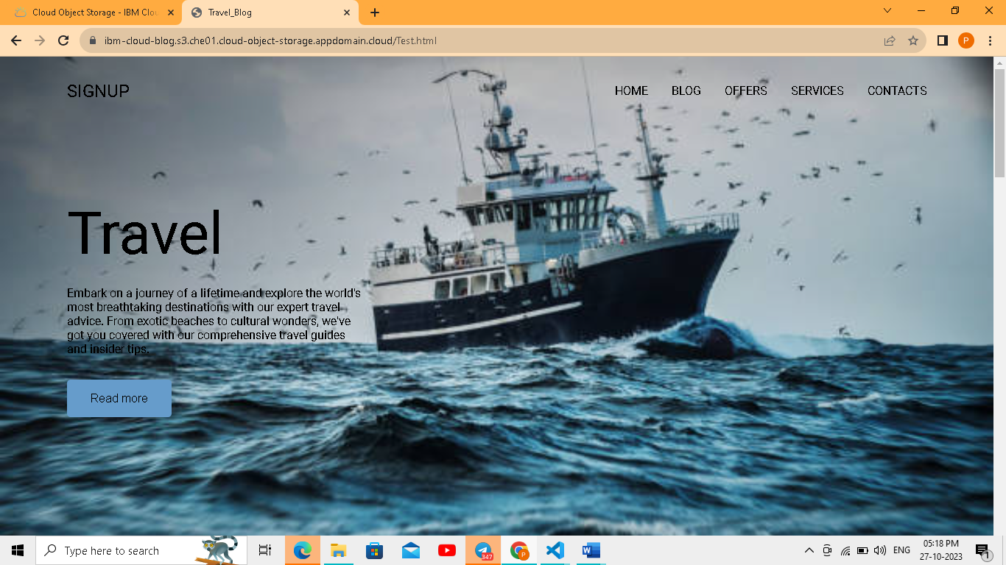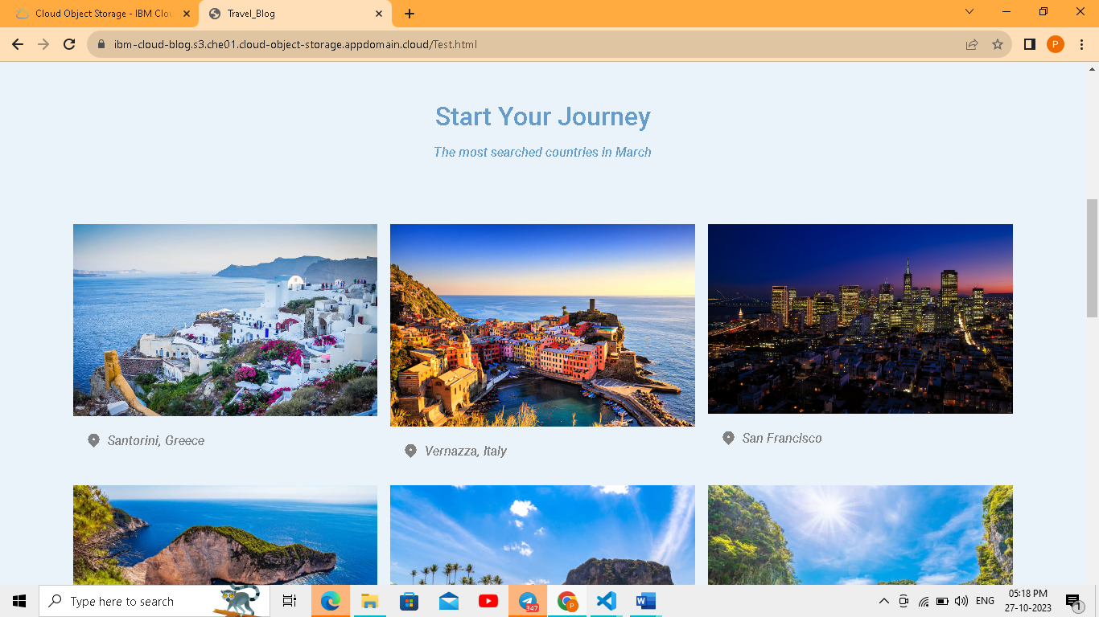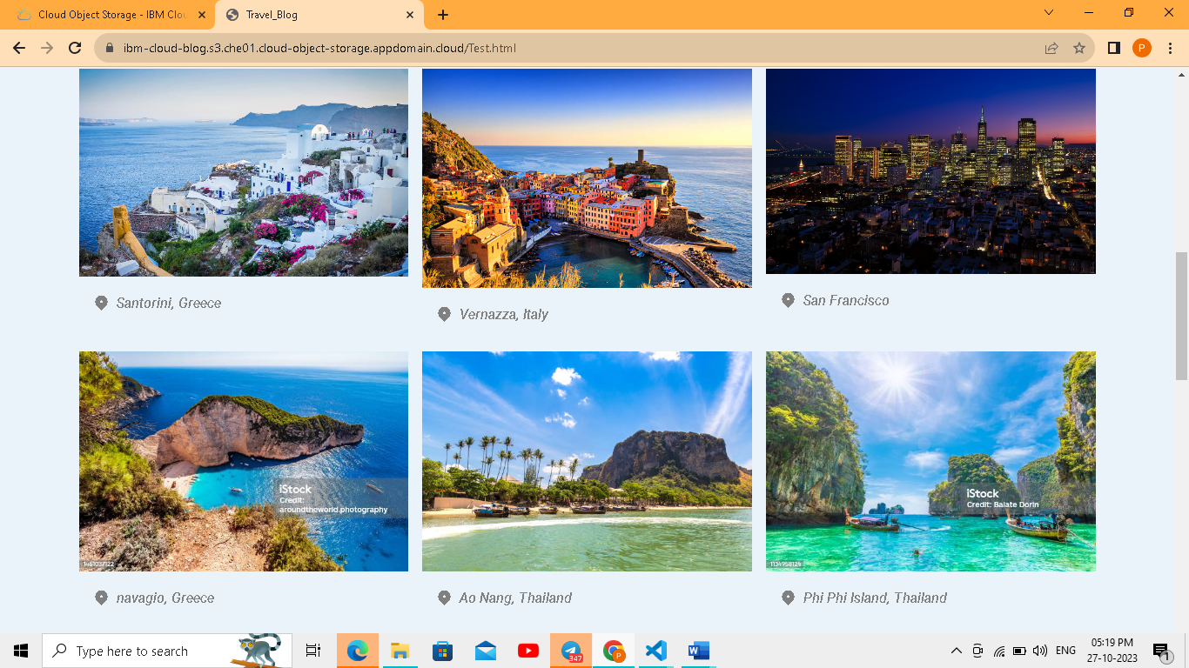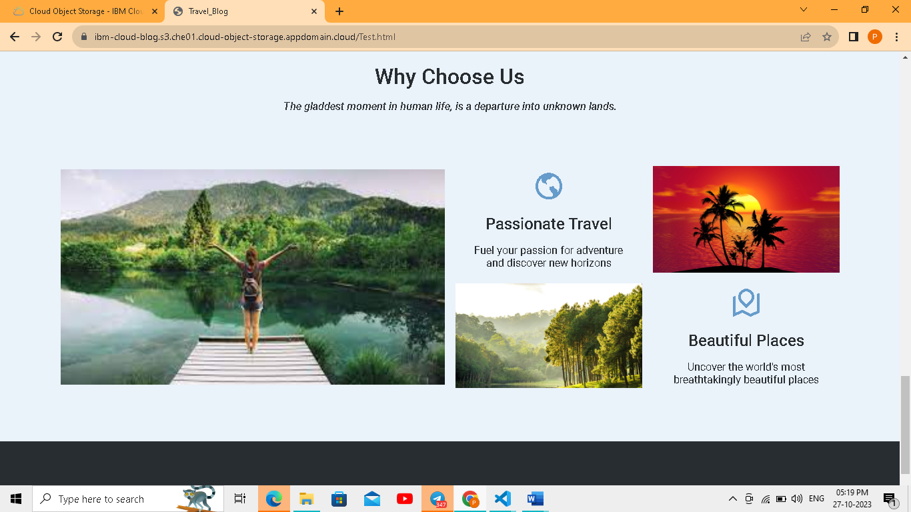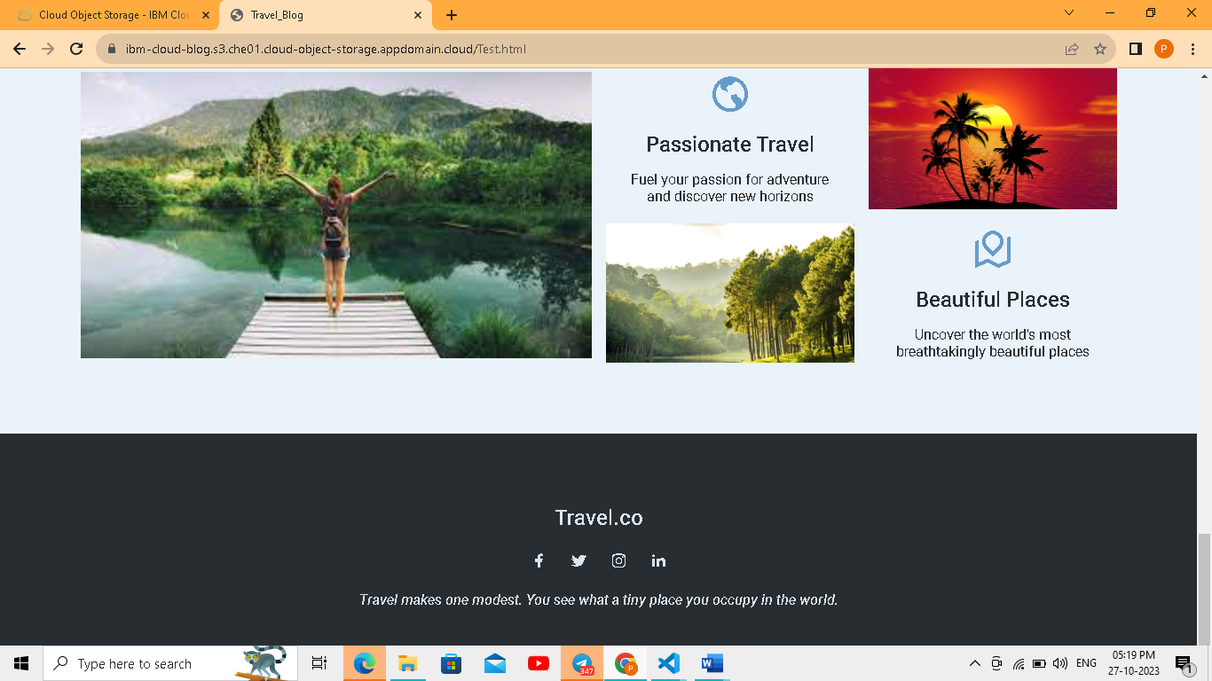

**Step18:**click the test.css file

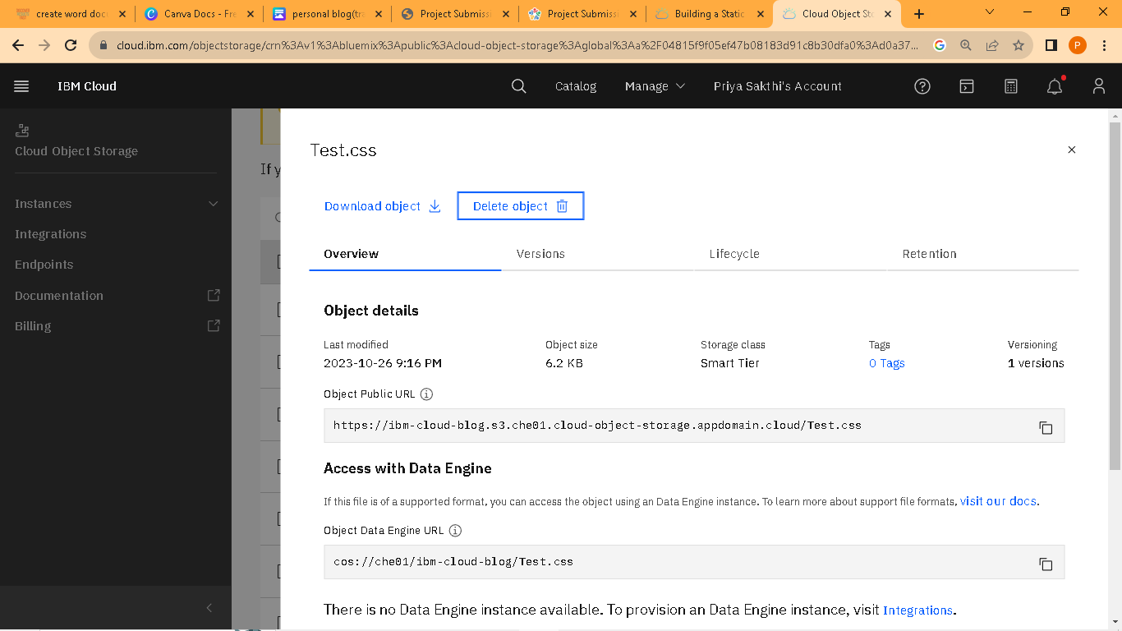

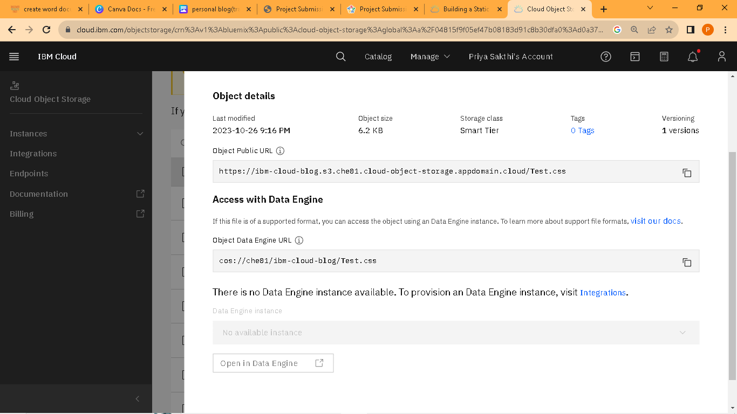

**Step19:**Copy the URL put into the new tab

https://ibm-cloud-blog.s3.che01.cloud-object-storage.appdomain.cloud/Test.css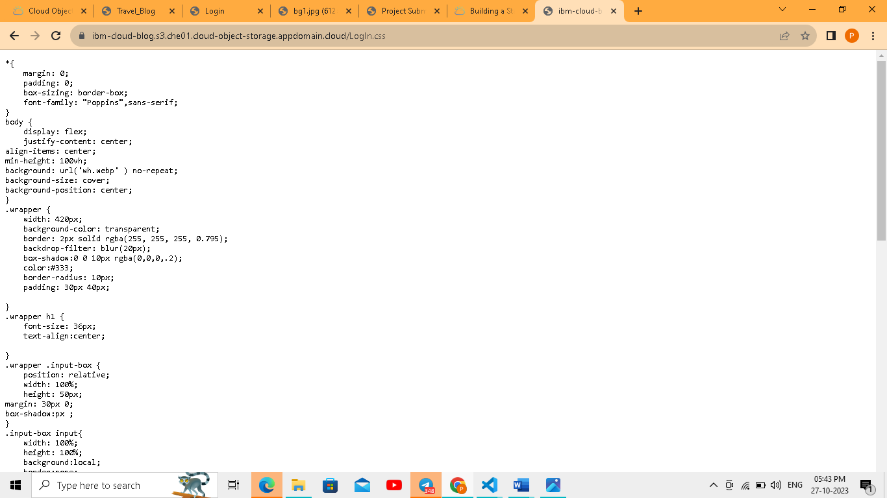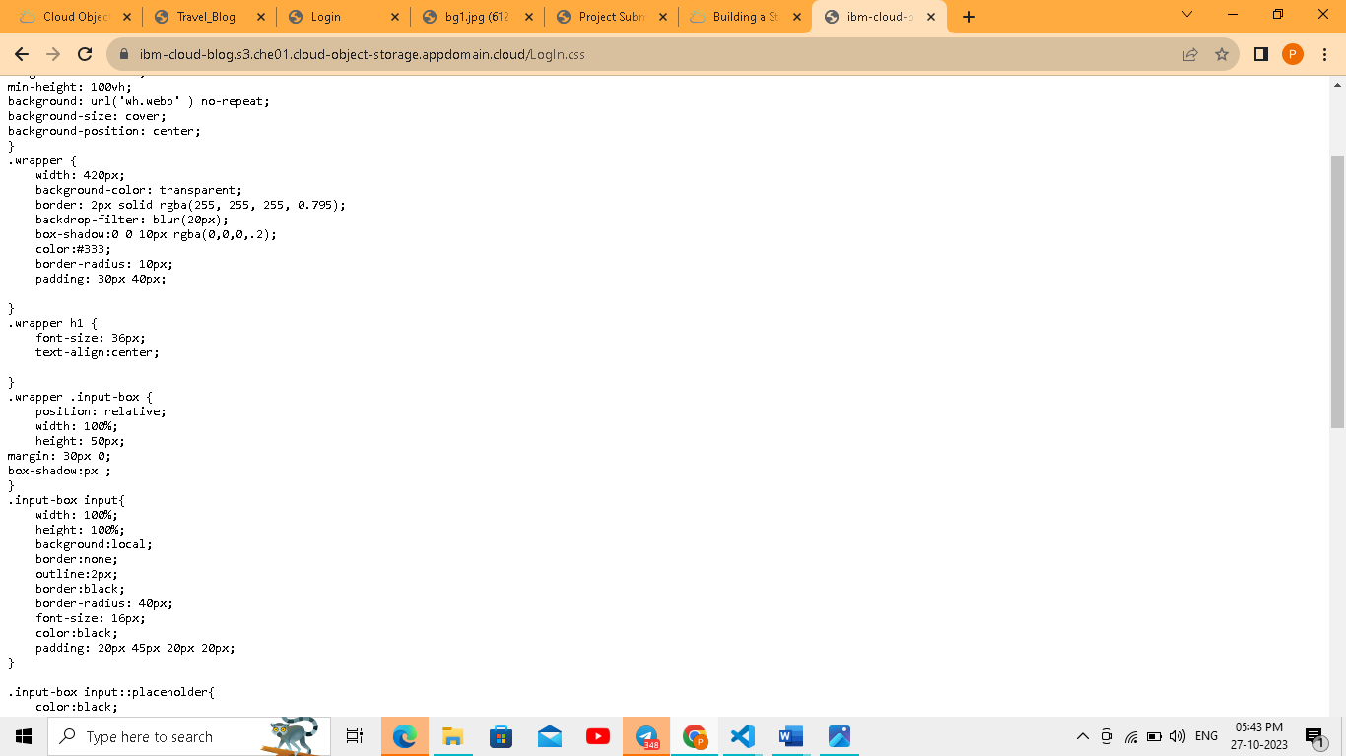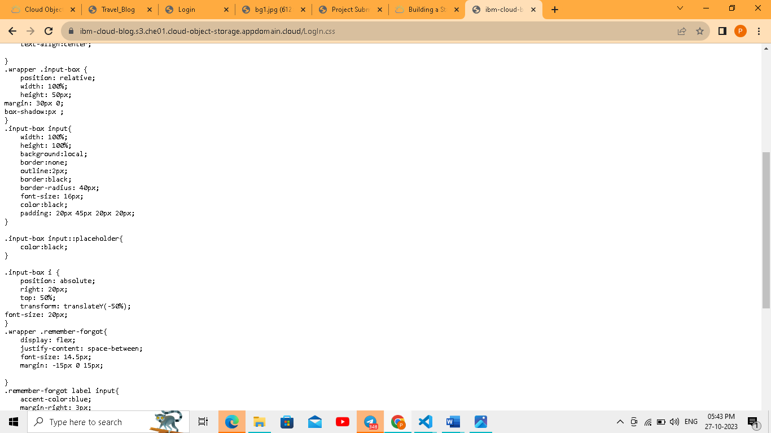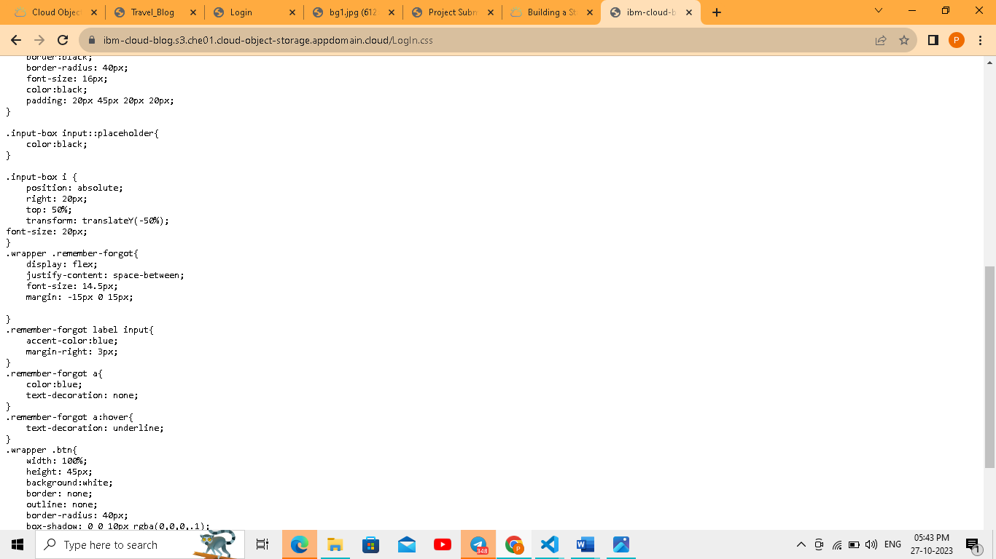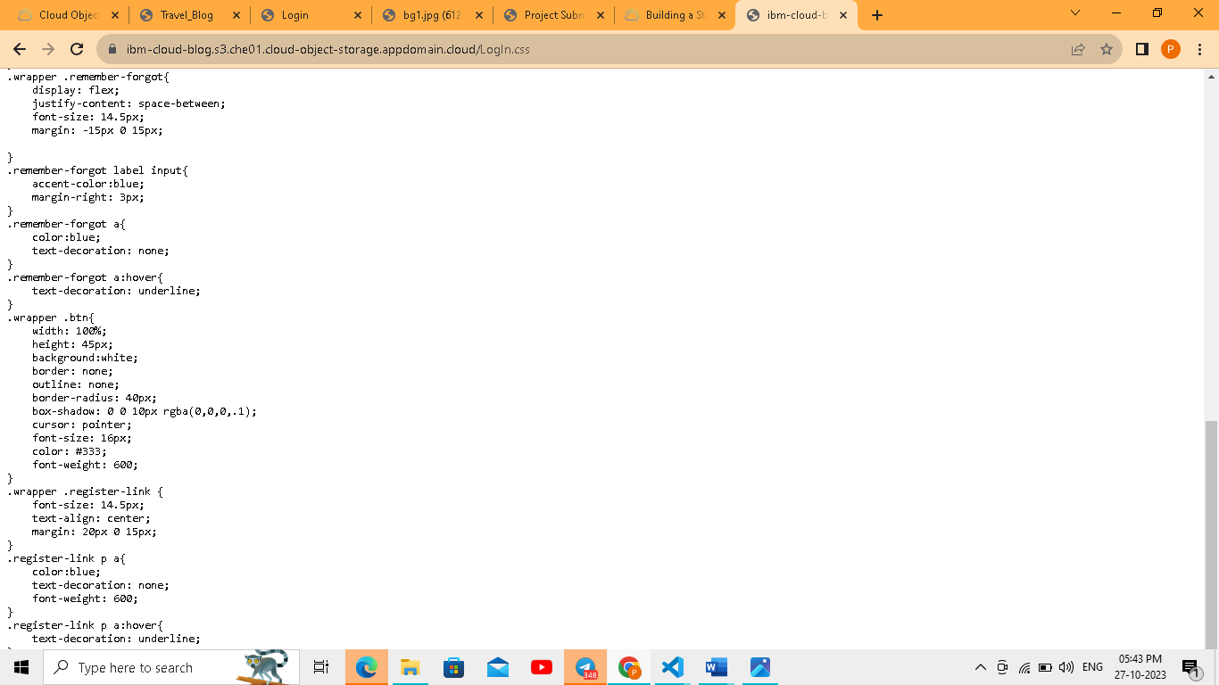

**Step20:click login.html file**

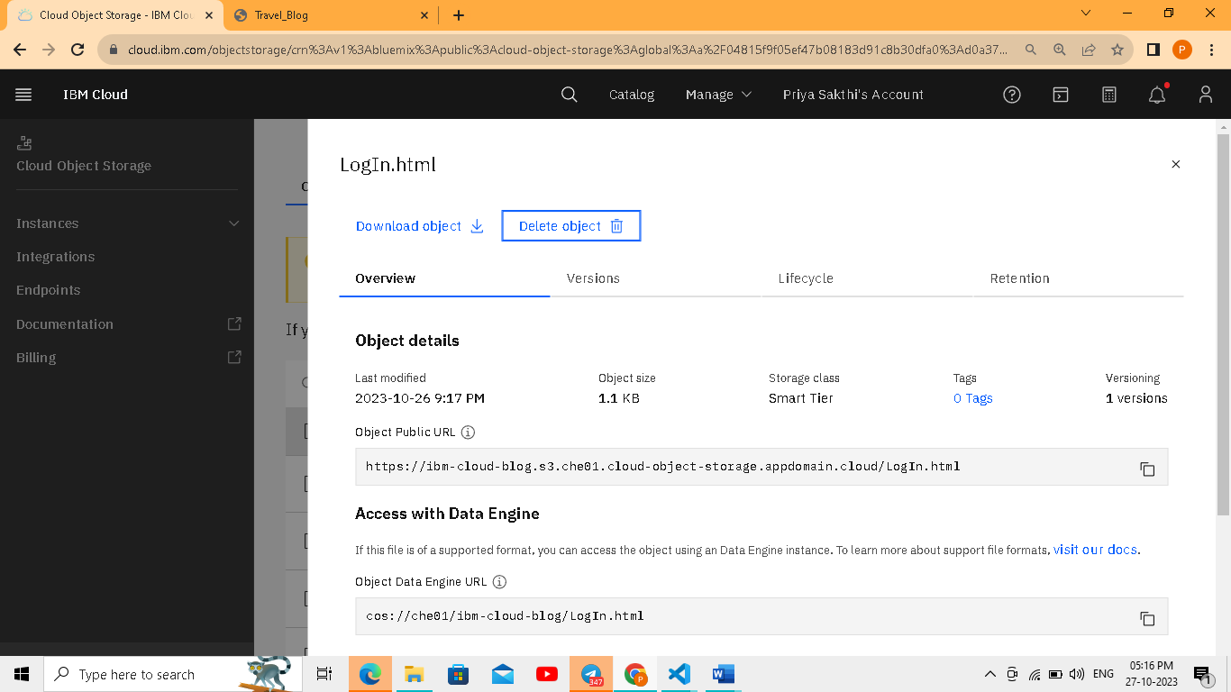

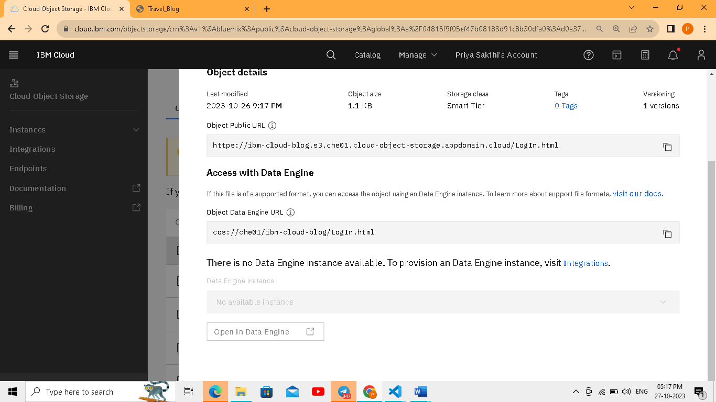

**Step21:**Copy the URL put into new tab

<https://ibm-cloud-blog.s3.che01.cloud-object-storage.appdomain.cloud/LogIn.html>

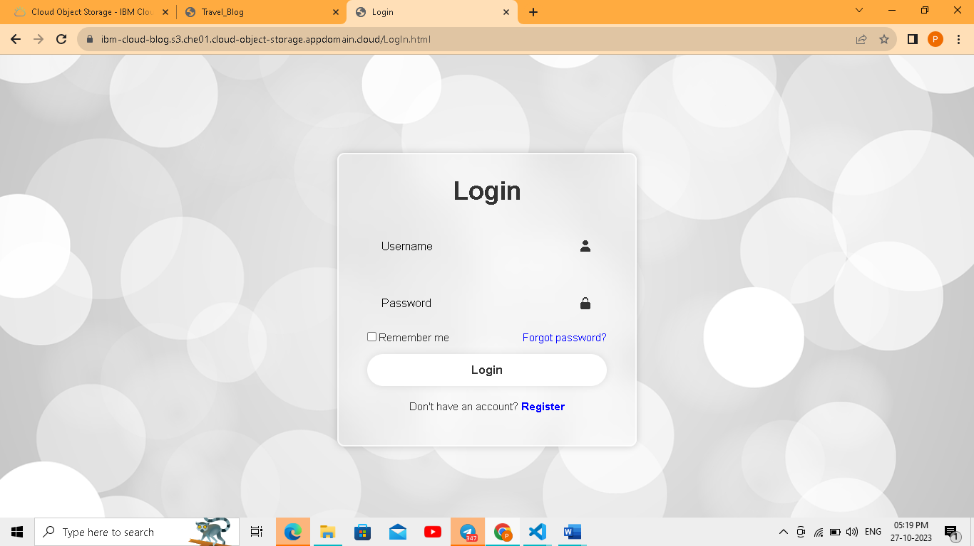

**Step22:**Click bg1 file

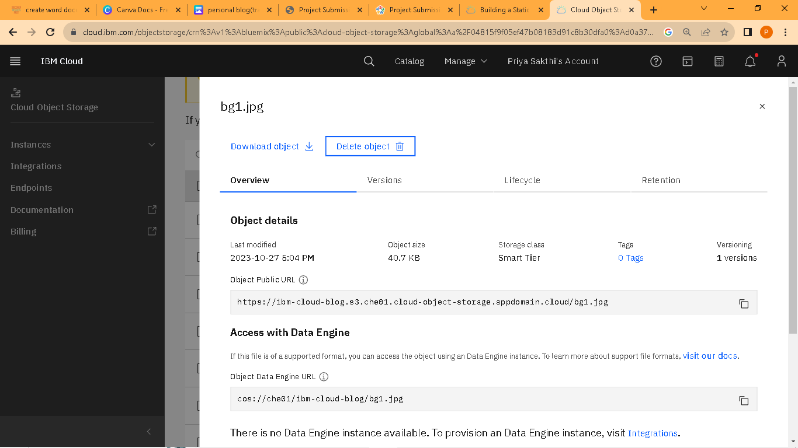

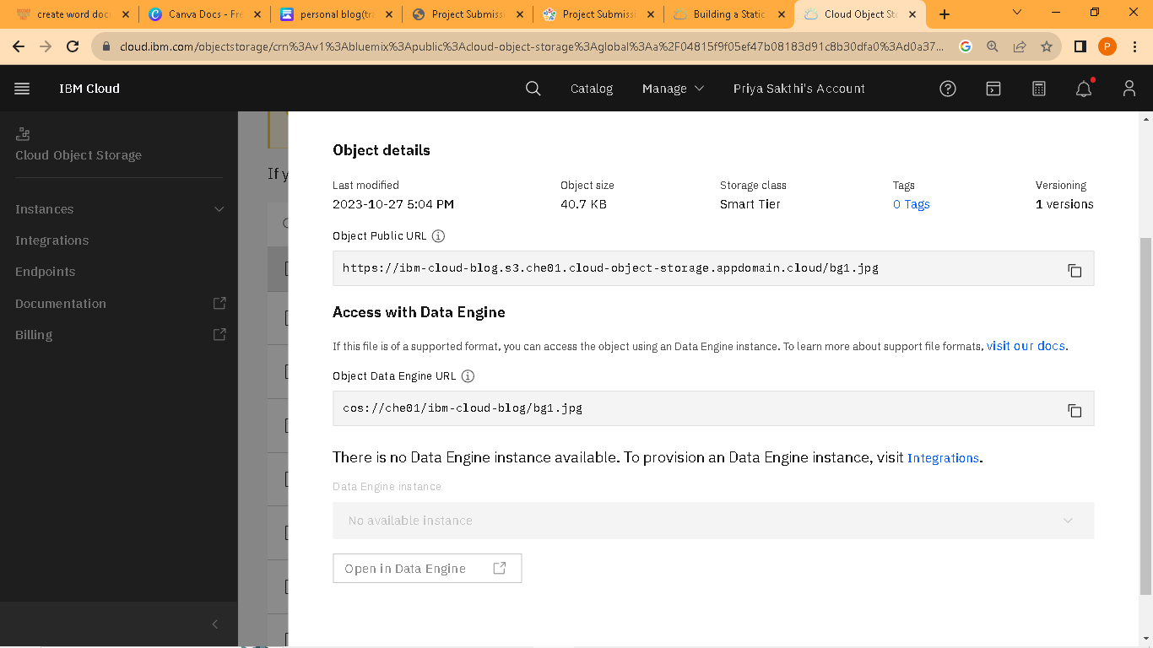

**Step23:**copy the URL put into the new tab

<https://ibm-cloud-blog.s3.che01.cloud-object-storage.appdomain.cloud/bg1.jpg>

